**CFD HW2**

The plots for first order finite volume code with Roe’s flux are shown below. It can be observed that the nature of the truncation error is dissipative.

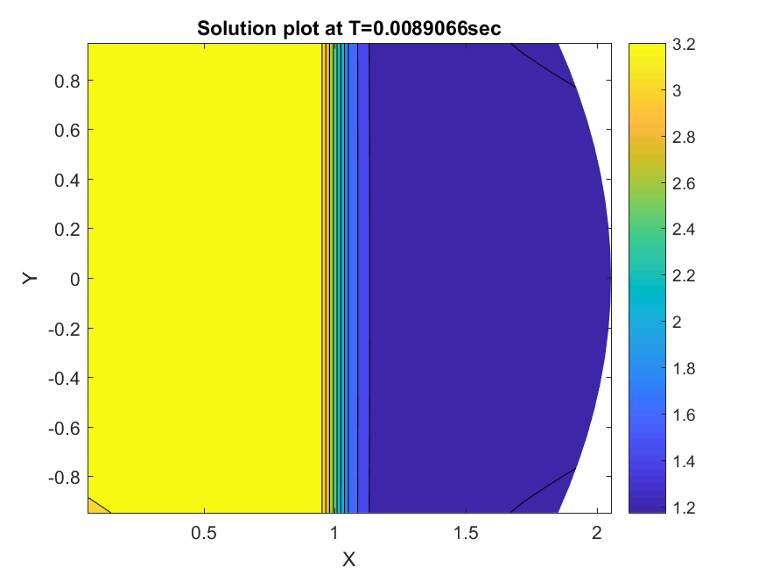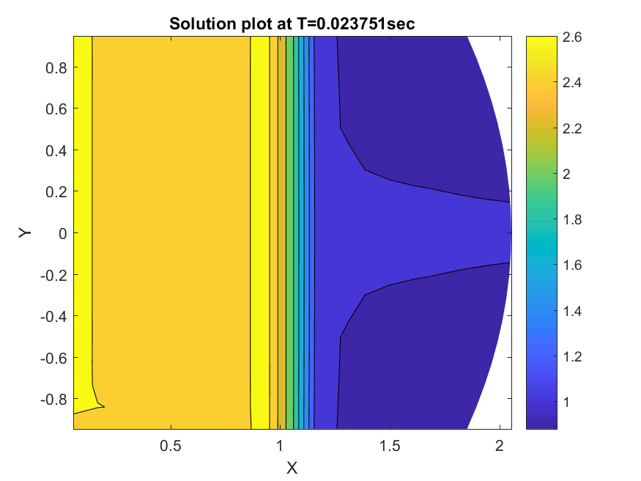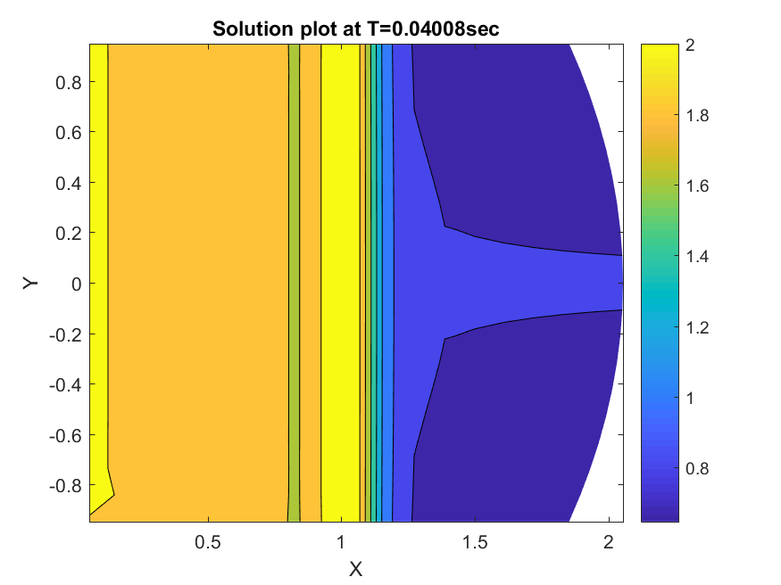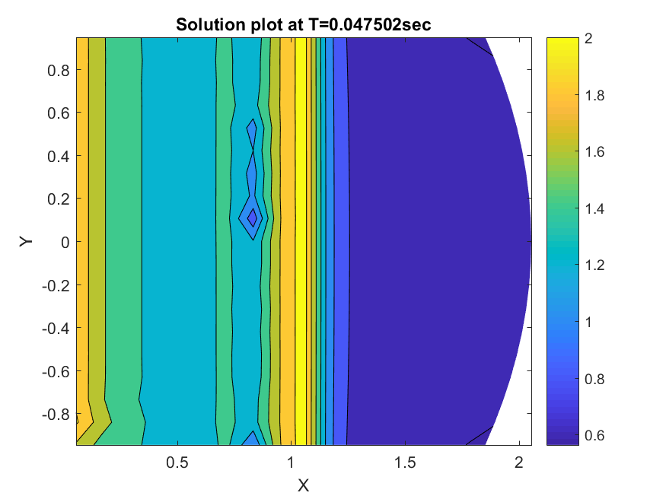

The results using first order finite volume method which uses rotated Riemann solver with entropy fix are shown in the figures below. Due to the usage of entropy fix, the results are better than the previous results

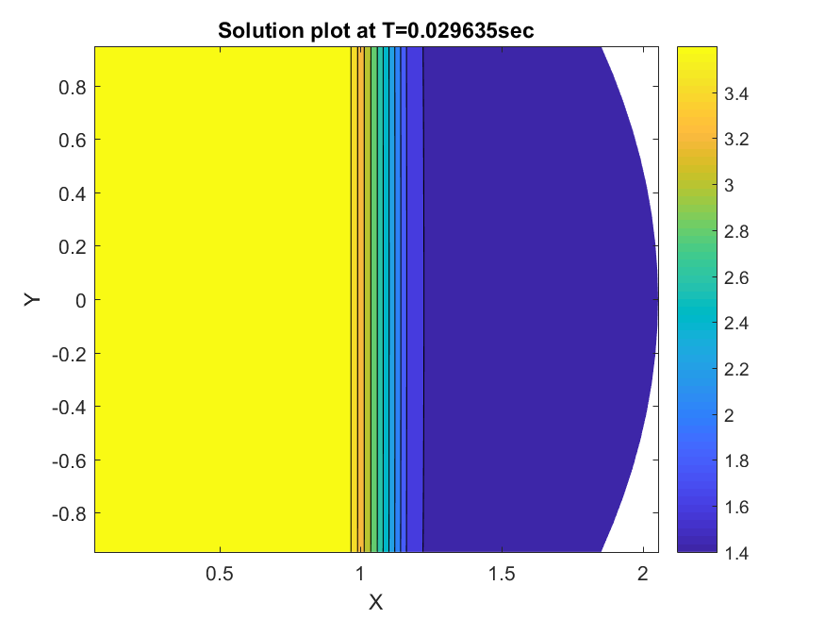

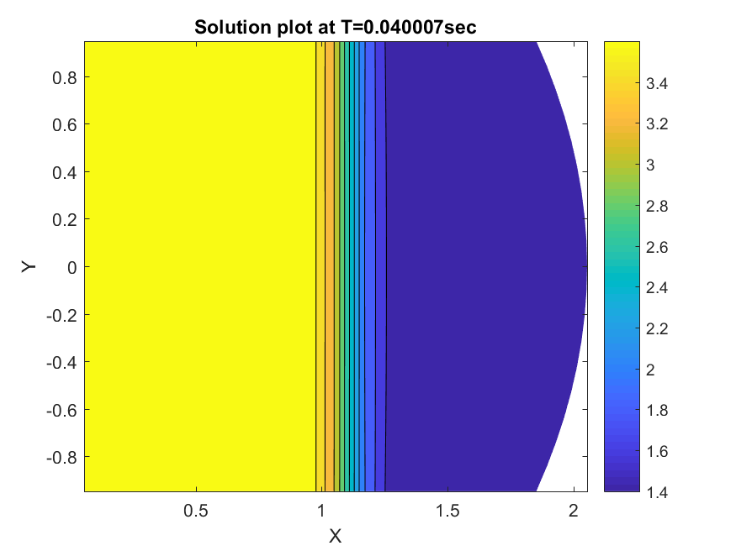

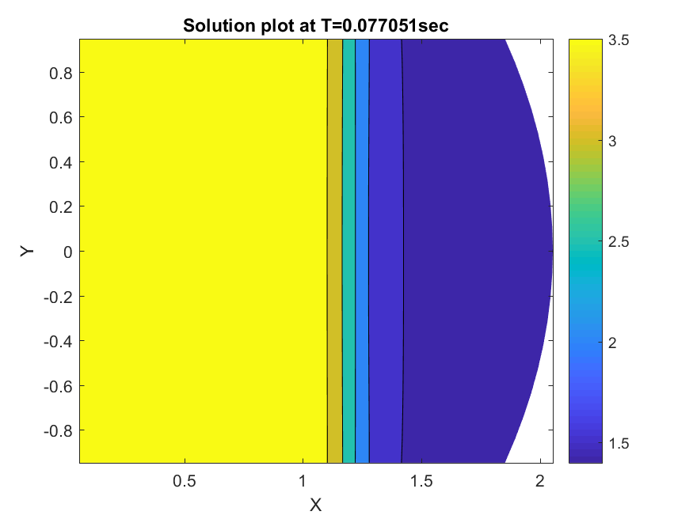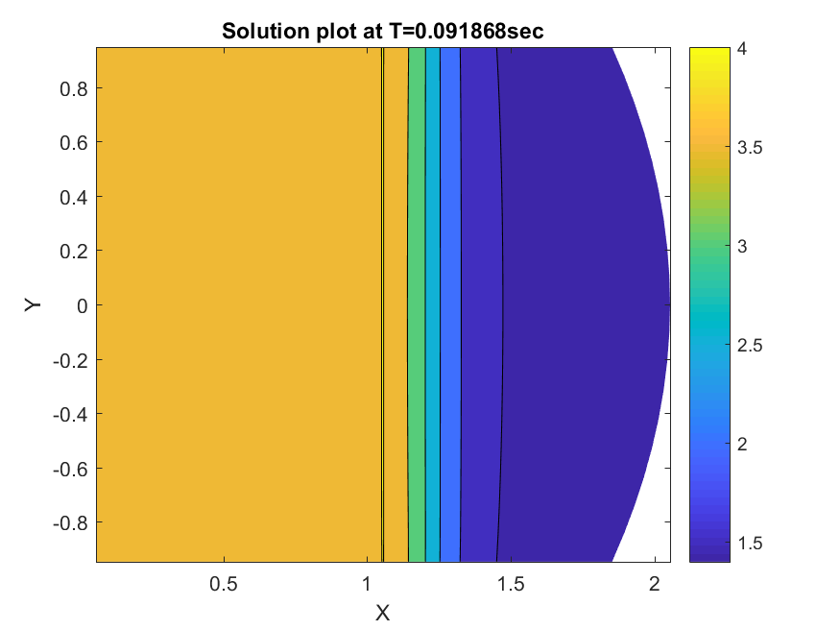

Grid Convergence is established by checking the L2 Norm of the density at different grid sizes. The following plot shows grid convergence for first order finite volume method.

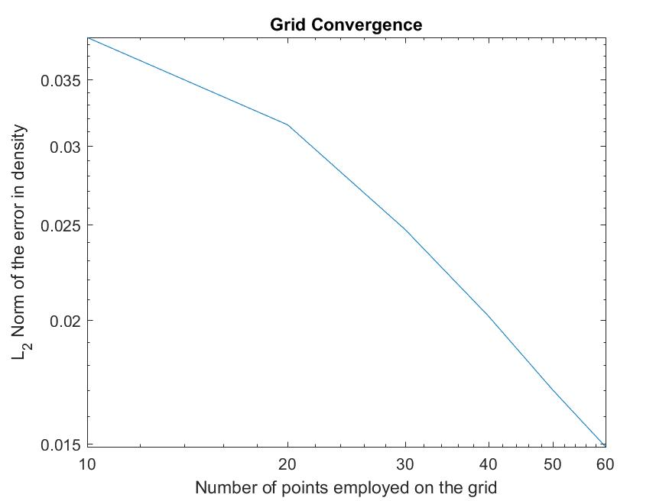

The plots for second order reconstruction without a limiter at different times are shown in the figures below. It can be observed that the oscillatory nature of the truncation error manifests itself in the visualization in the form of spikes of varying intensities.

